INDIVIDUAL PLANNING AND PROGRESS REPORT

Acme ANS

#### DELIVERABLE 1 DESING AND TESTING 2 2024-2025

|  |  |
| --- | --- |
| Date | Version |
| 02/16/2025 | V1.0 |

|  |  |
| --- | --- |
| Group: C1.053 | |
| Members | Email |
| Sánchez Márquez, Julia | [julsanmar2@alum.us.es](mailto:javgarrod5@alum.us.es) |
| García Rodríguez, Javier | [javgarrod5@alum.us.es](mailto:javgarrod5@alum.us.es) |
| González Ortiz, Miguel | [miggonort1@alum.us.es](mailto:miggonort1@alum.us.es) |
| Palomo García, Miguel | [migpalgar1@alum.us.es](mailto:migpalgar1@alum.us.es) |
| Periáñez Franco, Luis Javier | [luiperfra1@alum.us.es](mailto:luiperfra1@alum.us.es) |

#### GitHub repository: <https://github.com/miggonort1/Acme-ANS-D01>

TABLE OF CONTENTS

Executive summary 2

REVISION TABLE 3

INTRODUCTION 4

CONTENTS 5

1. PLANNING CHAPTER 5
   1. Tasks List 5
   2. Screenshots of different moments of the development 6
   3. Estimated cost 8
2. PROGRESS CHAPTER 8
   1. Progress records 8
   2. Conflicts and solutions 9
   3. Costs comparaison 9

CONCLUSIONS 10

BIBLIOGRAPHY 11

# EXECUTIVE SUMMARY

This report details the planning, execution and monitoring of the work carried out by the team within the framework of the first deliverable of the project. Throughout development, clear criteria have been established for the distribution of tasks, cost estimation and performance measurement of each team member.

In the planning phase, the tasks to be carried out were defined, assigning specific responsibilities to each member and estimating the times necessary for their execution. A structured methodology was used to ensure an efficient workflow, which allowed the team's organization to be optimized.

During the progress phase, detailed monitoring of each activity was carried out, evaluating compliance with deadlines and the quality of the work delivered. The comparison between estimated costs and actual costs has made it possible to identify possible adjustments in the planning of future deliverables.

The team has worked in a coordinated manner and without conflicts, which has facilitated the achievement of objectives in a timely manner. As a result, the deliverable has been completed satisfactorily, ensuring high quality standards and establishing a solid foundation for the next phases of the project.

# REVISION TABLE

|  |  |  |
| --- | --- | --- |
| Revision Number | Date | Description |
| V1.0 | 02/16/2025 | Verify everything is ok. |

# INTRODUCTION

This document details the planning and progress monitoring of the working group in relation to the assigned deliverable. Its purpose is to provide a structured overview of the tasks performed, the estimated and actual times, as well as an analysis of the team's management in terms of performance and conflict resolution.

This report is divided into two main chapters: Planning and Progress. In the Planning Chapter, the tasks defined to meet the requirements of the deliverable are presented, including their distribution among the team members, the estimated time for their execution, and a series of screenshots illustrating the evolution of the work in our project management tool. An estimated budget of the total cost of the deliverable is also included, taking into account the working hours per role and amortization costs.

The Progress Chapter documents the team's progress, recording individual and group performance indicators, difficulties faced and the strategies adopted to resolve them. A comparison is also made between the estimated cost and the actual cost of developing the delivery, with the aim of evaluating the accuracy of the planning and improving management in future iterations.

This report is a key element in the team's evaluation, as it allows the level of organization, efficiency and collaboration within the group to be measured. It has been prepared following the work methodology established in document “L01/S03 - Working together”, thus ensuring compliance with best practices in project management.

# CONTENTS

## PLANNING CHAPTER

### Tasks List

We have separated the tasks by students or groups. To make this possible we have created two different labels on GitHub, one called “Student” to make it clear that this task should only be done by a specific student, and the other label is called “Group” to make it clear that this task must be done by the whole group. Both group and student tasks start with the number 1.

|  |  |  |  |  |  |
| --- | --- | --- | --- | --- | --- |
| Task | Description | Assignee/s | Role/s | Planned time | Actual time |
| Task 001 | Customise developmen t  environment | Julia Sánchez | Developer- Testing | 30 minutes | 35 minutes |
| Task 002 | Modify the anonymus  menu | Julia Sánchez | Developer- Testing | 20 minutes | 28 minutes |
| Task 002/T1 | Test Task  002 | Julia  Sánchez | Developer-  Testing (QA) | 5 minutes | 5 minutes |
| Task 003 | Make Analysis  Report | Julia Sánchez | Developer- Testing | 1 hour | 1 hour |
| Task 004 | Make Planning and Progress  Report | Julia Sánchez | Developer- Testing | 1 hour | 1 hour |
| Task 003/T1 | Verify Task  003 is well completed | Julia Sánchez | Developer- Testing (QA) | 10 minutes | 5 minutes |
| Task 004/T1 | Verify Task 004 is well  completed | Julia Sánchez | Developer- Testing (QA) | 10 minutes | 5 minutes |
| Task 001 | Make Chartering Report | Grupal: Miguel Palomo, Luis Periañez, Miguel  Gonzalez, | Developer- Testing | 1 hour | 50 minutes |

|  |  |  |  |  |  |
| --- | --- | --- | --- | --- | --- |
|  |  | Javier  García, Julia Sánchez |  |  |  |

### Screenshots of different moments of the development

* 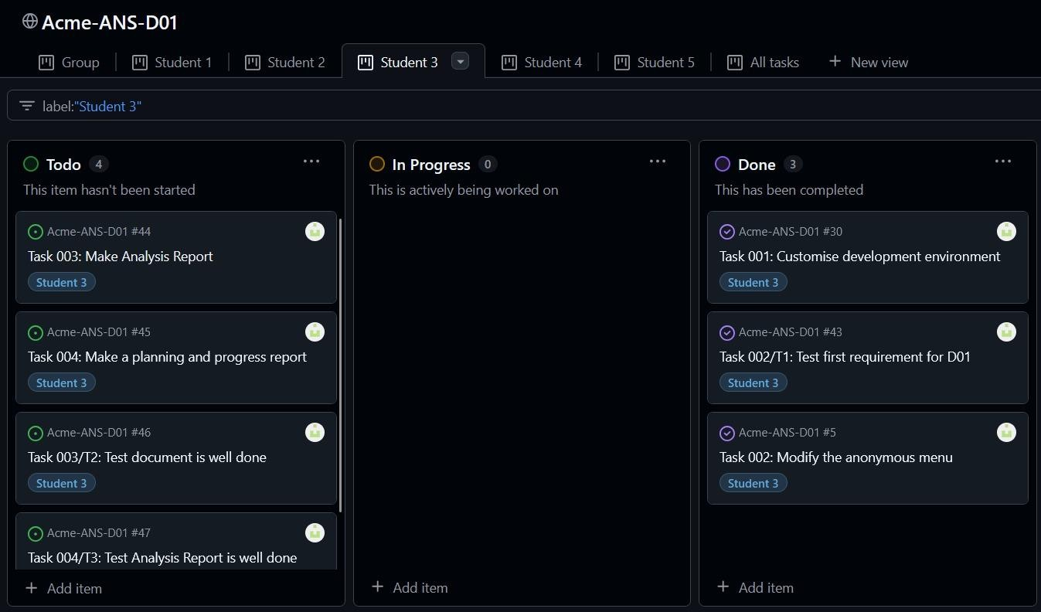Screenshot 1: Initial definition of all tasks in the "to do".

Screenshot 1

* 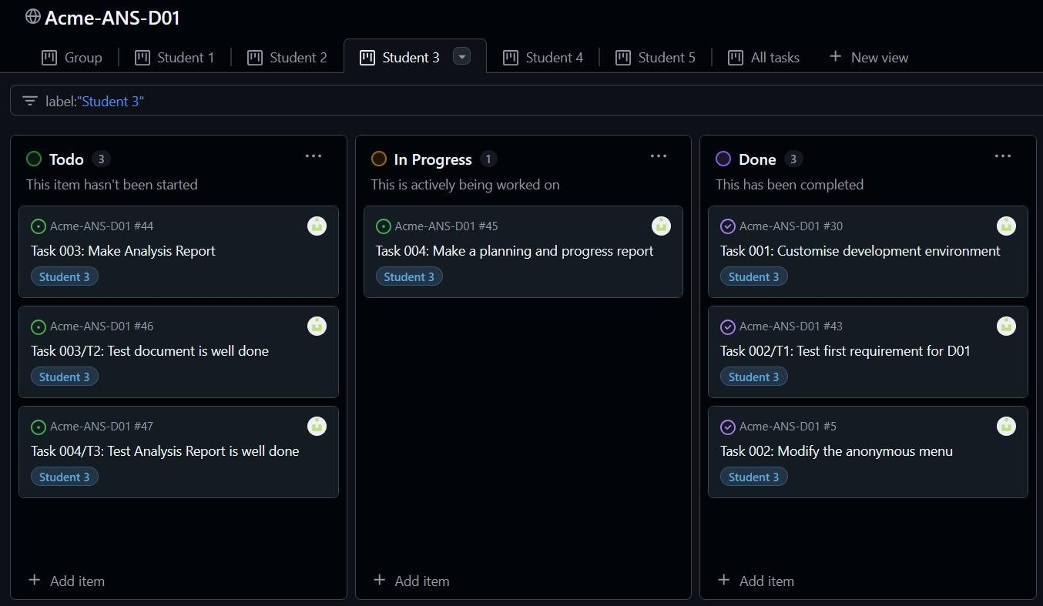Screenshot 2: Intermediate state of tasks “In Progress”.

Screenshot 2

#### Screenshot 3: Tasks finished in “Done”.

#### Screenshot 3 Student 3

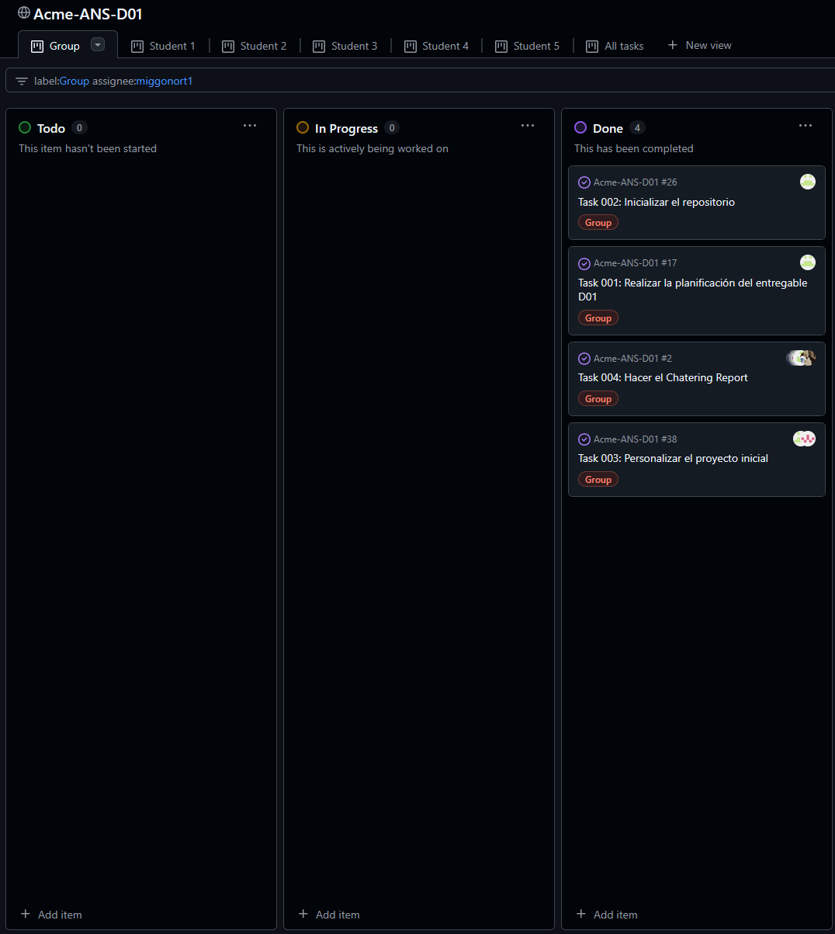

#### Screenshot 3 Group

### Estimated cost

|  |  |  |  |  |
| --- | --- | --- | --- | --- |
| Rol | Estimated  Hours | Personnal Cost  (€) | Amortisation  Cost (€) | Total Cost (€) |
| Manager | 9 h | 30/h | 62.50 / 4 =  15.63 | 285.63 |
| Developer | 5 h | 20/h | 62.50 / 4 =  15.63 | 40.63 |
| Tester | 10 mins | 20/h | 62.50 / 4 =  15.63 | 18.63 |
| Operator | 0 h | 20/h | 62.50 / 4 =  15.63 | 0 |

## PROGRESS CHAPTER

### Progress records

|  |  |  |  |
| --- | --- | --- | --- |
| Member | Performance  Indicator | Evaluation | Reward /  Admonishment |
| Julia Sánchez Márquez | - 100% Quality of work  - 100%  Contribution to the team  - 100%  Punctuality  - 100%  Achievement of objectives | Mean: 100% Good job | Team praise |
| García Rodríguez, Javier | - 100% Quality of work  - 100%  Contribution to the team  - 100%  Punctuality  - 100%  Achievement of objectives | Mean: 100% Good job | Team praise |
| González Ortiz, Miguel | - 100% Quality of work  - 100%  Contribution to the team  - 100%  Punctuality  - 100%  Achievement of objectives | Mean: 100% Good job | Team praise |
| Palomo García, Miguel | - 100% Quality of work  - 100%  Contribution to the team | Mean: 100% Good job | Team praise |

|  |  |  |  |
| --- | --- | --- | --- |
|  | - 100%  Punctuality  - 100%  Achievement of objectives |  |  |
| Periáñez Franco, Luis Javier | - 100% Quality of work  - 100%  Contribution to the team  - 100%  Punctuality  - 100%  Achievement of objectives | Mean: 100% Good job | Team praise |

### Conflicts and solutions

There have been no conflicts during this deliverable.

### Costs comparaison

|  |  |  |  |  |
| --- | --- | --- | --- | --- |
| Rol | Hours Spent | Personnel Cost  (€) | Amortisation  Cost (€) | Total Cost (€) |
| Manager | 18 h | 30/h | 62.50 / 4 =  15.63 | 555.63 |
| Developer | 10 h | 20/h | 62.50 / 4 =  15.63 | 215.63 |
| Tester | 10 mins | 20/h | 62.50 / 4 =  15.63 | 18.63 |
| Operator | 0 h | 20/h | 62.50 / 4 =  15.63 | 0 |

# CONCLUSIONS

The development of this deliverable has allowed us to evaluate the team's ability to plan, organize and execute tasks efficiently within the estimated time. Through the correct distribution of responsibilities and monitoring progress, we have managed to meet the established objectives, ensuring quality and punctuality in the delivery of each task.

The analysis of estimated costs versus actual costs has allowed us to identify areas for improvement in planning and resource allocation. Although the deviation has been minimal, the importance of an accurate estimate of the time and effort required for each task has been evident.

In addition, the team has maintained fluid and effective communication, which has favored the agile resolution of any problem and has avoided the appearance of conflicts during this phase of the project. This has been key to ensuring harmonious collaboration and coordinated work.

As a learning, in future iterations we will seek to improve the accuracy in estimating the required effort and further optimize task allocation. Likewise, we will maintain the methodology applied to promote an efficient and collaborative work environment.

In conclusion, this deliverable has been a success both in terms of management and execution, providing a solid foundation for the next developments of the project.

# BIBLIOGRAPHY

#### Intentionally blank.